Project Design Phase
Solution Architecture
Date | 15 July 2026
Team ID
Project Name | UCab Premium – Cab Booking Application
Maximum Marks | 4 Marks

Solution Architecture Overview
UCab Premium follows a three-tier MERN architecture that bridges rider/driver needs with a secure, scalable backend:
- Client Tier: React (Vite) single-page application serving Rider, Driver, and Admin portals.
- Application/API Tier: Node.js with Express, structured using the MVC pattern, exposing 35 REST endpoints.
- Security Layer: JWT-based authentication and role-based access control (RBAC) gate every protected route.
- Data Tier: MongoDB Community Server with 5 collections — Users, Drivers, Bookings, Payments, and Reviews.
- Supporting Services: PDFKit for trip receipt generation, Recharts for admin analytics visualization, and an email service for registration/confirmation notifications.

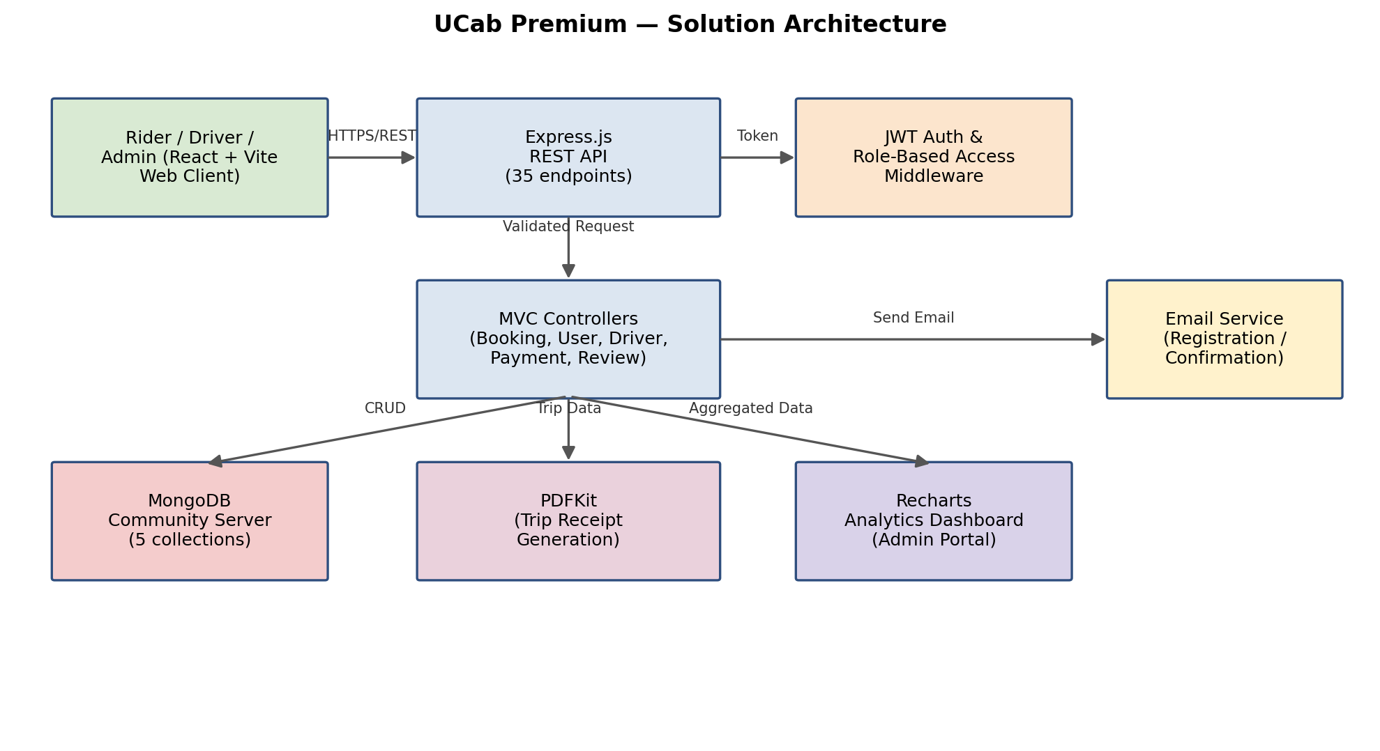
Figure 1: Architecture and data flow of UCab Premium

Booking Lifecycle (State Machine)
Every booking moves through a five-stage lifecycle, enforced at the API layer: Pending → Driver Assigned → Accepted → On the Way → Completed, with Cancelled as an exit state reachable from any stage before completion.

Reference
Internal design reference: SmartBridge Full Stack Development internship — UCab Premium (MERN stack) project documentation.

